**SonarQube Integration for a PHP project**

**Purpose**:

Enables the powerful SonarPHP code analyzer.

**Requirements:**

* PHPUnit
* PHP-XDebug
* SonarQube LTS
* SonarPHP
* Sonar Runner / Scanner

**Installing SonarQube:**

Install the SonarQube and creating new project.

**Configure SonarQube for PHP analysis:**

To analyze PHP source code you must install the PHP Plugin.

***Step1***: Select the Settings menu from the top bar and choose System | Update Center. In the Update Center

***Step2*** : Select the Available Plugins tab to see the plugins you can install. Under the Languages you will find PHP.

***Step3*** :Click the link to see the details including an Install button.

***Step4*** : Click the Install button to make SonarQube retrieve the plugin

***Step5*** : Restart the Sonar Qube Service.

**Analyzing PHP source code:**

SonarQube is now ready to analyze you PHP project. To perform the analysis you have to execute a runner.

There are several runners, and here I use the SonarQube Runner / Scanner. This is a runner which is executed from a command line. Other runners are available to perform the analysis as part of a **Maven** or **Ant** build.

The SonarQube Runner/Scanner is not included in the SonarQube download, you need to download it separately.

***Downloading the sonar-scanner-cli-3.x.x-linux.zip | windows***

Next step is to configure the analysis of your code. The SonarQube Runner expects a file called sonar-project.properties where you put that configuration.

Create a file called sonar-project.properties in the root directory the project you want to analyse with SonarQube. This file is needed to configure the SonarQube Runner.

These are the basic properties you should include:

sonar.projectKey=your:project-key

sonar.projectName=Project name

sonar.projectVersion=1.0

sonar.language=php

sonar.sources=.

sonar.sourceEncoding=UTF-8

Open a new command prompt window, change the current directory to the directory with the PHP code and the sonar-project.properties file. Now run the analysis by executing the command sonar-runner.

**Example:**

“D:\xampp\htdocs\magento2>D:\sonar-scanner\bin\sonar-scanner –X”

Note: If all went well you will see a notification EXECUTION SUCCESS in the console output.

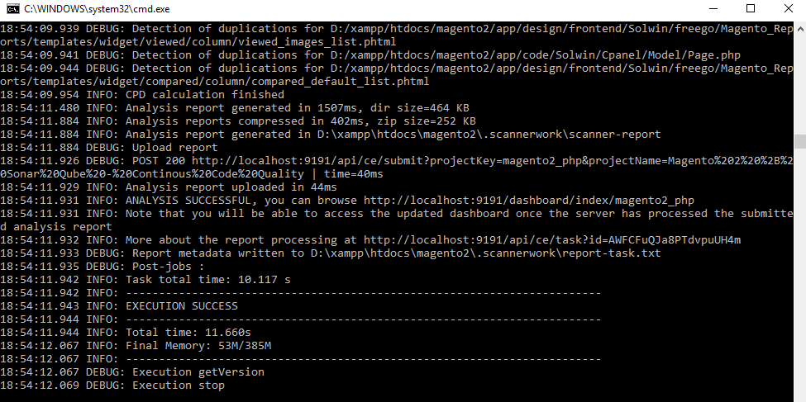

**Viewing the analysis report:**

Open the web interface. You should see your project listed on the home page. Click the link and you can browse all the information collected by SonarQube.

